Università degli Studi di Trento  School of International Studies | Master’s Degree in European and International Studies  English Language  Reading Comprehension  Text 1 | 2012 – 2013  17 June 201
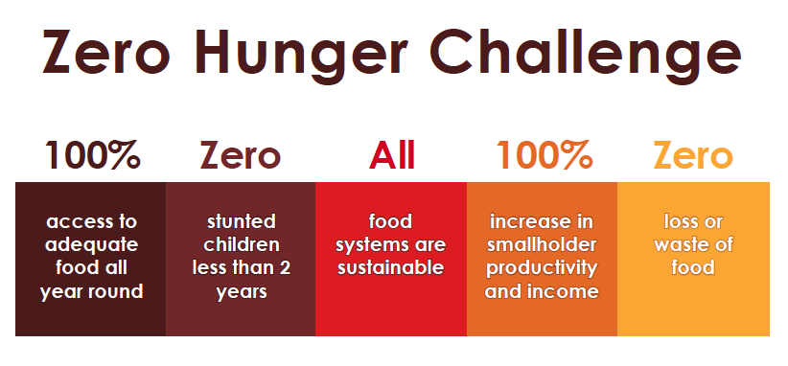
Hunger can be eliminated in our lifetimes.
In the text below, the first word of each paragraph is missing. Select a suitable word from the ones in the box to complete the paragraphs. Some of the words may be used more than once. Some of the words are not used. Write the correct word in the space on the answer sheet.
The UN Secretary-General encourages all partners to scale up their efforts and turn the vision of an end to hunger into a reality. What does this mean?
100% access to adequate food all year round
1) … all people to access the food they need at all times through nutrition-sensitive agriculture and food systems, marketing, decent and productive employment, a social protection floor, targeted safety nets and food assistance; boosting food supply from local producers; through open, fair and well-functioning markets and trade policies at local, regional and international level, preventing excessive food price volatility.
Zero stunted children less than 2 years
2) … universal access to nutritious food in the 1000-day window of opportunity between the start of pregnancy and a child’s second birthday, supported by nutrition-sensitive health care, water, sanitation, education and specific nutrition interventions, coupled with initiatives that enable empowerment of women, as encouraged within the Movement for Scaling Up Nutrition.
All food systems are sustainable
3) … that all farmers, agribusinesses, cooperatives, governments, unions and civil society establish standards for sustainability; verifying their observance and being accountable for them; encouraging and rewarding universal adoption of sustainable and climate-resilient agriculture practices; pursuing cross-sectoral policy coherence (encompassing energy, land use, water and climate); implementing responsible governance of land, fisheries and forests.
100% increase in smallholder productivity and income
4) … rural poverty and improving wellbeing through encouraging decent work, and increasing smallholders’ income; empowering women, small farmers, fishers, pastoralists, young people, farmer organizations, indigenous people and their communities; supporting agricultural research and innovation; improving land tenure, access to assets and to natural resources, making sure that all investments in agriculture and value chains are responsible and accountable; developing multidimensional indicators for people’s resilience and wellbeing.
Zero loss or waste of food
5) … food losses during storage and transport, and waste of food by retailers and consumers; empowering consumer choice through appropriate labelling; commitments by producers, retailers and consumers within all nations; achieving progress through financial incentives, collective pledges, locally-relevant technologies and changed behaviour.

Reducing Enabling Ensuring Minimising Raising Encouraging Empowering Allowing

