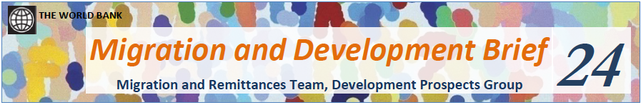
In the text below, an extract from the World Bank Migration and Development Brief, fill the gaps with the correct form of one of the verbs from the box below. Please note that not all the verbs are used. You may have to make some of the verbs passive and sometimes the position of the adverb may have to change. Note also that No. 13 appears twice as the same verb is used twice in the text.

record predict pretend register
restrict facilitate retain moderate
expect raise remain recover
balance fix lead offset
bring estimate contract enhance
reach get keep rise

April 13, 2015
Migration and Remittances: Recent Developments and Outlook* Special Topic: Financing for Development
• Using newly available census data, the stock of international migrants 1) ……………………………………. at 247 million in 2013, significantly larger than the previous estimate of 232 million, and 2) ……………………………… to surpass 250 million in 2015.
• Migrants’ remittances to developing countries are estimated 3) ………………………………… $436 billion in 2014, a 4.4 percent increase over the 2013 level. All developing regions 4) ………………………………… positive growth except Europe and Central Asia (ECA), where remittance flows 5) ………………………… due to the deterioration of the Russian economy and the depreciation of the ruble.
• In 2015, however, the growth of remittance flows to developing countries is expected 6) ……………………….. sharply to 0.9 percent to $440 billion, 7) ………………………………… by a 12.7 percent decline in ECA and slowdown in East Asia and the Pacific, Middle-East and North Africa, and Sub-Saharan Africa. The positive impact on flows of a robust recovery in the US 8) ………………………………… partially by continued weakness in Europe, the impact of lower oil prices on the Russian economy, the strengthening of the US dollar, and tighter immigration controls in many source countries for remittances. Remittance flows are expected to
9) ………………………………… in 2016 to reach $479 billion by 2017, in line with the more positive global economic outlook.
• The global average cost for sending money 10) ………………………………… broadly at 8 percent in Q4 2014, with the highest average cost (about 12 percent) in Sub-Saharan Africa. Concerns over money laundering 11) ………………………………… costs high by increasing compliance costs for commercial banks and money transfer operators, and delaying the entry of new players and the use of mobile technology.
• In the context of the global deliberations on financing the implementation of Post-2015 development goals, migration and remittances can be leveraged 12) ………………………………… development financing via reducing remittance costs, lowering recruitment costs for low-skilled migrant workers, and mobilizing diaspora savings and diaspora philanthropic contributions. Remittances can also be used as collateral, through future-flow securitization, 13) ………………………………… international borrowings with possibly lower costs and longer maturities. And they can 13) ………………………………… access to international capital markets by improving sovereign ratings and debt sustainability of recipient countries.
In the following extract from the Brief, fill in each gap with ONE suitable word.
1.3 Factors affecting migration and remittance flows in 2014
The following had a 1) ………………………….. impact on global migration and remittance flows in 2014: (a) the uneven recovery in developed countries; (b) lower oil prices and economic developments in Russia; (c)
2) ………………………….. immigration controls; and (d) conflicts that are 3) ………………………….. forced migration and internal displacement.
Uneven economic recovery in developed countries
The robust recovery in the United States 4) ………………………….. remittances outflows in 2014. For example, remittances to Mexico, El Salvador, Guatemala, Honduras, and Nicaragua rose with the increase 5)………………………….. US housing construction and in employment in the services sector, including hotels and restaurants. 6) ………………………….. contrast, the weak recovery in the Euro Area 7) ………………………….. remittance flows to developing countries. For instance, remittances to several Latin American countries have been 7) ………………………….. by the slowdown and high unemployment rate in Spain, which hosts a 8)………………………….. percentage of all Latin American migrants. And remittances to Maghreb countries, where Europe is the 9) ………………………….. source of remittances, slowed in 2014.
Lower oil prices and the Russian economy
The 10) ………………………….. in oil prices and the impact of economic sanctions 11) ………………………….. a heavy toll on the Russian economy in 2014. Countries that are heavily dependent on remittances from Russia, for example Armenia, Georgia, the Kyrgyz Republic, and Tajikistan, experienced a 12) ………………………….. drop in remittances in the fourth quarter. Moreover, the depreciation of the ruble 13) ………………………….. the dollar and most CIS currencies has reduced the purchasing power of remittances from Russia, particularly affecting the 14) ………………………….. of poor households in the Central Asian countries.
On the other hand, the fall 15) ………………………….. oil prices does not appear to have reduced remittances from Gulf Cooperation Council (GCC) members, especially to India, Bangladesh, Nepal, Pakistan, and several countries in the Middle East and North Africa. The 16) ………………………….., however, is uncertain. The substantial financial resources and long-term infrastructure development plans of the GCC countries imply that they will continue to demand migrant workers. However, remittance flows could decline if the oil price 17) ………………………….. to remain low for a few years.
The impact of slow growth on remittance outflows measured 18) ………………………….. dollars is compounded by the valuation effects of the U.S. dollar appreciation against the currencies of remittance source countries. The anticipated tightening of monetary conditions in the United States, 19) ………………… with monetary expansion by other major central banks, has been associated with a significant increase in the dollar’s 20) ………………………….. since the middle of 2014. The euro fell by 19 percent against the dollar from the second quarter for 2014 to the second quarter of 2015, and the ruble by 34 percent.
Conclude this section with a commentary for the following Table.
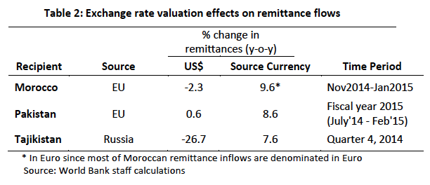
1.2 Global remittance trends and outlook
Below are some of the Figures and Tables from section 1.2 of the Brief. You should write 2-3 short paragraphs commenting on the information portrayed in these tables and figures. Please remember that the Brief was published in April 2015 and that all figures for 2014 to 2017 are forecast figures and not verified data.
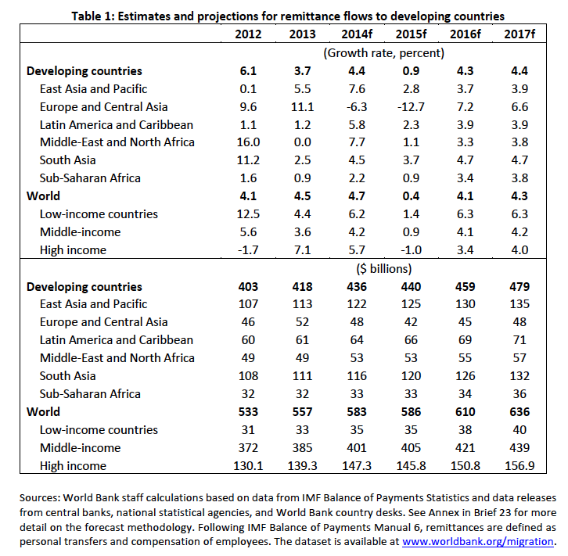

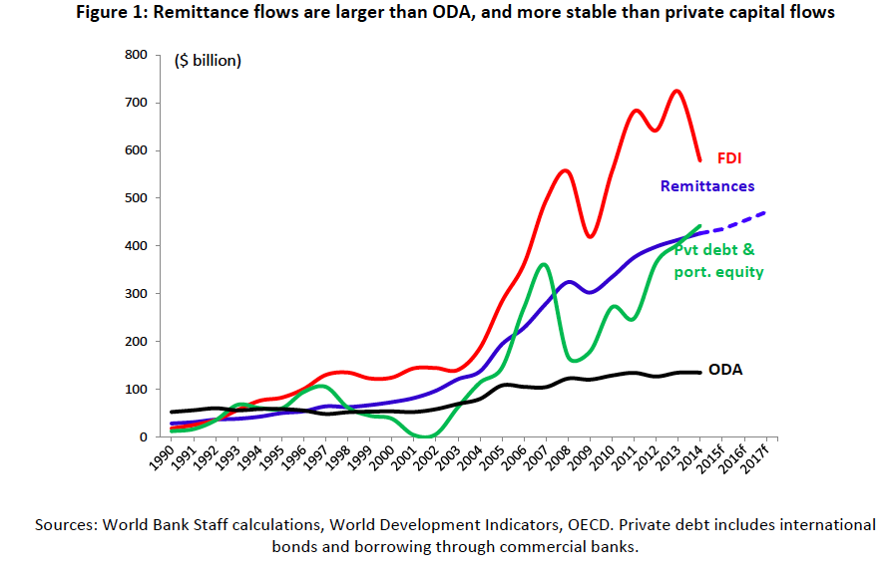
Figure 2: Remittances by volume and percent of GDP
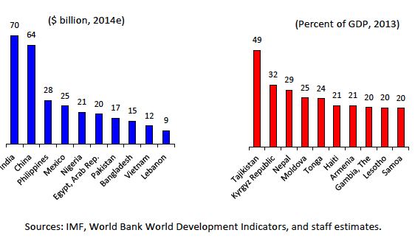

2 Remittance Costs
2.1 Global trends and outlook for remittance costs
Write a paragraph describing the tables and figures below from Brief No. 25.
Figure 3: The cost of sending remittences
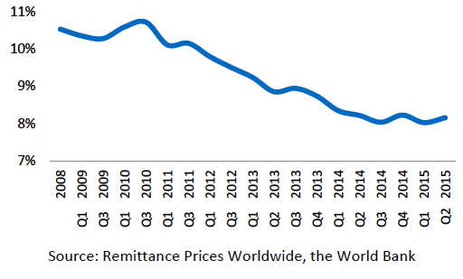

Figure 4: Costs per Remittance Service Provider
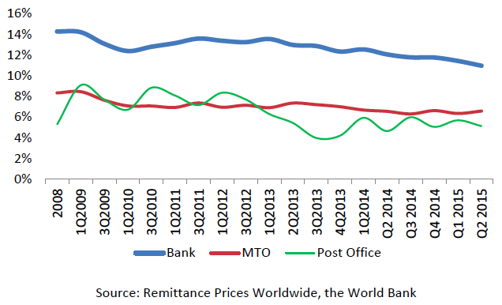MTO = Money Transfer Operators

Figure 5: Average cost of sending remittances by area

